Clare Mount Specialist Sports College
PSHE- Autumn Term 1 Newsletter 2026
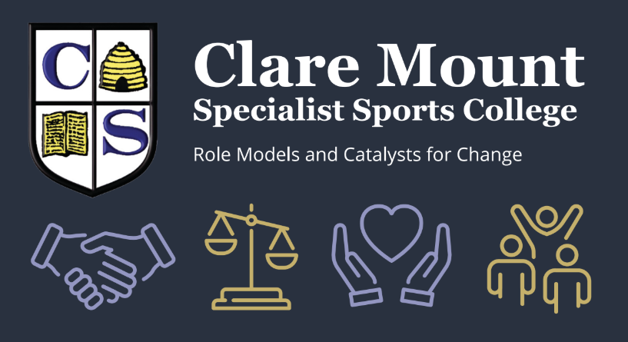
Welcome Back Message – September 2026
Dear Parents and Carers,
Welcome back! We are excited to see all of our young people return after the summer break. At Clare Mount, your child’s Personal Development is one of our main priorities, and we are committed to providing a wide range of opportunities to help them grow and thrive.
Personal Development forms part of our School Focus Priorities (FP5: Personal Development & Wellbeing), which aims:
“To nurture and grow ‘happy, healthy’ individuals who have tools for managing their physical, social and mental health, and aspire to be ‘fit for every lesson’.”

Understanding Your Child’s Timetable
This year, you may notice a number of codes on your child’s timetable. Each represents a lesson that supports their Personal Development:
- PSHE – Personal, Social, Health and Economic Education: A statutory curriculum subject in England covering Relationships Education, Relationships and Sex Education (RSE), and Health Education. It equips pupils with the knowledge, skills, and understanding to manage their lives now and in the future.
- PFA – Preparation for Adulthood: Focused on employment/higher education, independent living, participation in society, and supporting good health. Particularly important for young people with SEND as they transition into adult life.
- Pol-Ed – Taken by Years 8 and 9. This develops knowledge and skills to help pupils become active, responsible citizens, understanding how to remain safe both in the physical world and online.
- PSD – Personal and Social Development: In Years 10 and 11, this combines aspects of PSHE and PFA, tailored to the academic pathway each student follows.

Our Curriculum This Half Term
We begin the year with our PSHE spiral curriculum, where all students revisit and build on key themes each year. This half term, every year group is focusing on “Being Me” – exploring their identity and where they fit into the world around them.
- Year 7 – Rights, respect, and boundaries; friendships; peer pressure; British Values.
- Year 8 – Self-identity; influences; stereotypes; the Equality Act 2010 (protected characteristics); respect for different faiths; diversity in British society.
- Year 9 – Identity and belonging; peer approval; county lines; risk and consent; healthy and unhealthy relationships.
- Year 10 – Human rights; how to end relationships safely; loss and grief; age ratings and the law; planning for the future.
- Year 11 – Preparing for adulthood; relationships, consent and the law; radicalisation and extremism; misogyny and sextortion.

Working Together
As always, if you would like support in discussing any of these topics at home, or if you would like further information, please don’t hesitate to get in touch. We also wanted to thank you for taking the time to consider our updated policy in line with the governments statutory requirements. The deadline for our parent/carer questionnaire is Friday 18th September.
Best wishes,
Mrs H. Jones
PSHE Subject Lead
📧 h.jones@claremount.wirral.sch.uk

