Clare Mount Specialist Sports College

SMSC (Spiritual, Moral, Social and Cultural) Policy

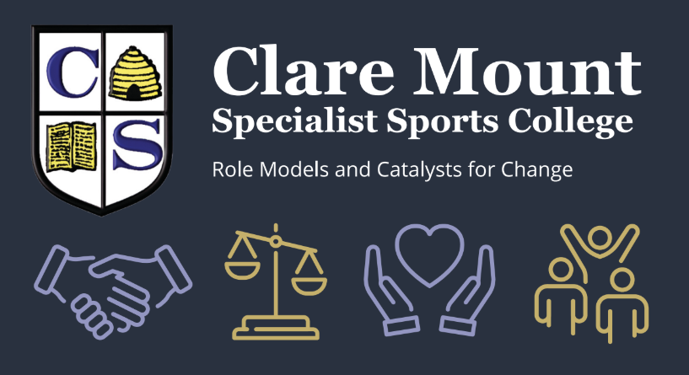

Name of school | Clare Mount Specialist Sports College
Date of policy | September 2026
Member of staff responsible | Mrs H Jones
Policy approved by | Governing Body
Review date | September 2027

Clare Mount Specialist Sports College

SMSC (Spiritual, Moral, Social and Cultural) Policy

Policy Statement
At Clare Mount Specialist Sports College, we are committed to supporting the development of the whole child. As a specialist SEND school, we recognise that pupils require opportunities, guidance, and support to develop spiritually, morally, socially, and culturally in ways that are accessible, meaningful, and relevant to their individual needs.
Through our curriculum, therapeutic approach, enrichment opportunities, relationships, and wider school ethos, we aim to prepare students for adulthood, promote positive well-being, and enable pupils to become respectful, resilient, and active members of society.
SMSC development underpins all aspects of school life and is embedded across the curriculum, pastoral support, personal development provision, and extracurricular activities.

Aims
The aims of this policy are to:
- Promote the personal development and wellbeing of all pupils.
- Foster confidence, resilience, independence, and self-esteem.
- Support pupils in understanding themselves and others.
- Encourage respect, empathy, tolerance, and kindness.
- Prepare pupils for life in modern Britain.
- Celebrate diversity and challenge discrimination, prejudice, and intolerance.
- Provide pupils with opportunities to develop socially, emotionally, morally, spiritually, and culturally.
- Encourage students to become responsible citizens who contribute positively to their community.
- Ensure SMSC development is accessible and appropriate for all pupils regardless of need or ability.

Definition of SMSC

Spiritual Development
Spiritual development at Clare Mount Specialist Sports College involves:
- Developing self-awareness, confidence, and emotional understanding.
- Encouraging reflection on feelings, experiences, beliefs, and values.
- Providing opportunities for creativity, imagination, curiosity, and enjoyment.
- Supporting pupils to develop resilience and a sense of achievement.
- Promoting mindfulness, emotional regulation, and well-being.
- Encouraging appreciation of nature, sport, music, art, and the wider world.
- Providing opportunities to explore different faiths, beliefs, and worldviews in a respectful and inclusive way.
Examples within school may include:
- Reflection activities during tutor time or assemblies.
- Mindfulness and well-being activities built into PSHE lessons and the wider curriculum.
- Therapeutic interventions.
- Religious Education lessons.
- Creative arts, music, drama, and sports participation.
- Celebrations of achievement and personal growth.

Moral Development
Moral development supports pupils in understanding right and wrong and making positive choices.
This includes:
- Understanding rules, boundaries, and consequences.
- Developing empathy and compassion.
- Learning about fairness, justice, equality, and responsibility.
- Encouraging honesty, integrity, and accountability.
- Challenging bullying, discrimination, prejudice, and harmful behaviour.
- Supporting pupils to reflect on

Policy review and approval
 | Headteacher | Chair of Governors
Name
Date / Signature

