Clare Mount Specialist Sports College
Personal Development and Culture Curriculum Roadmap
2026-2027
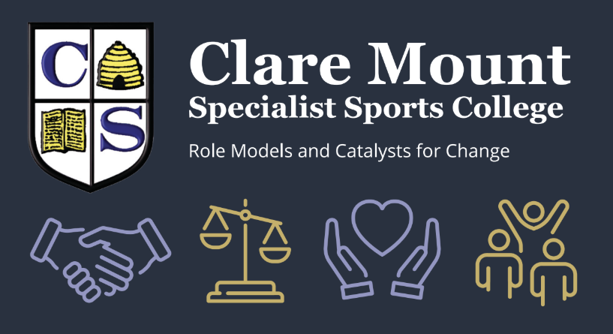
Week | September | British Values  - Democracy  - Rule of Law  - Individual Liberty  - Mutual Respect  - Tolerance of those with different faiths/beliefs | Awareness Days/Weeks | Religious Festivals/Cultural Celebrations | Monday Assembly | EDI (Equality, Diversity and Inclusion) Links | Skills Builder  Theme | CM School Value  Respect  Independence  Gratitude  Honesty  Trust | Trips/  Workshops/  Visiting Speakers | Enrichment Clubs  and  Opportunities  throughout the  Curriculum
Week 1  1st – 4th | September | Mutual Respect | 5th - International Day of Charity |  | INSET | PD resource | 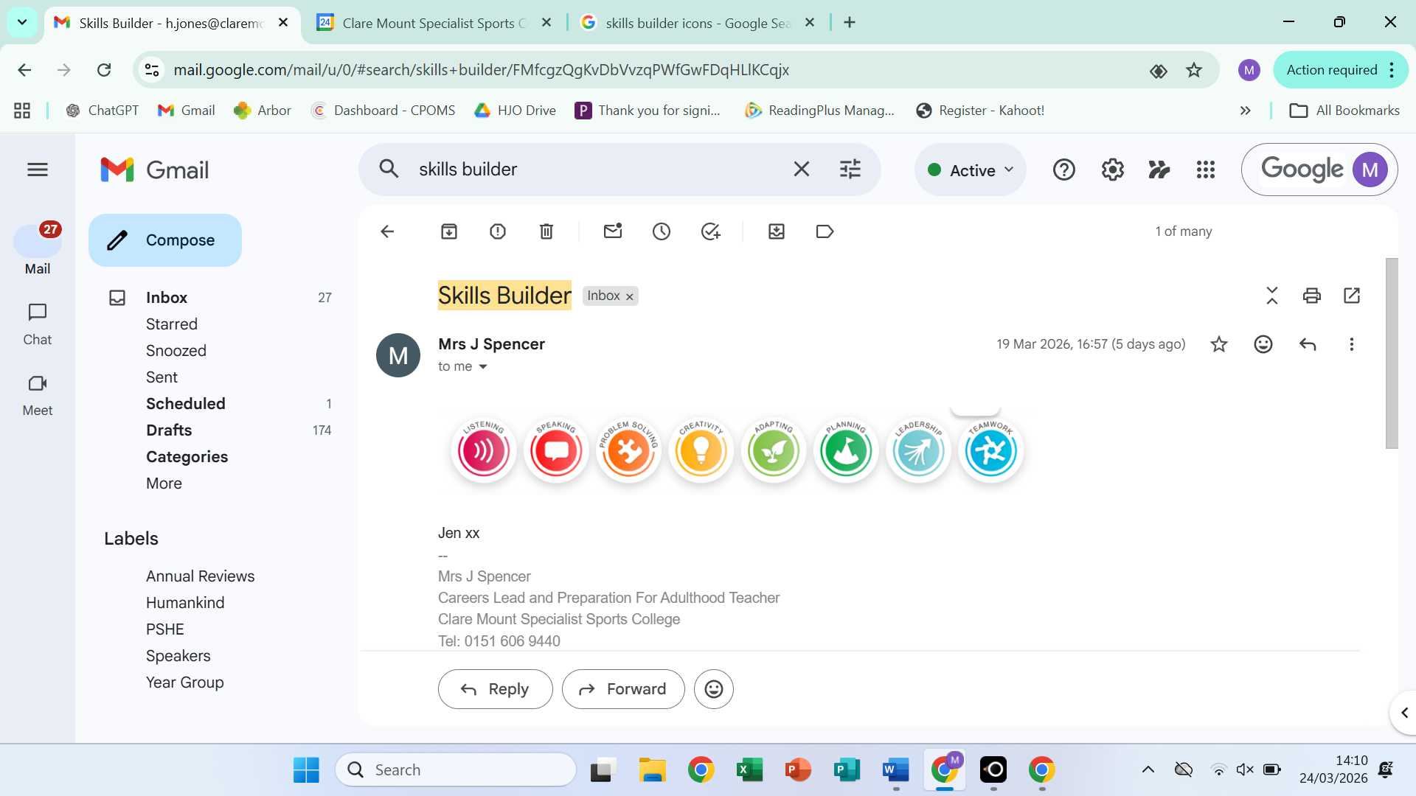  New school/new teachers/ routines.  Settled and Safe. | Gratitude – we are more fortunate than others.
Week 2  7th - 11th | September | Tolerance of Different Faiths |  | 11th-13th Rosh Hashanah | Whole  School  Welcome back | Assembly + PD resource | Assembly | Respect – all people deserve to be respected. Re-establish school values.
Week 3  14th – 18th | September | Democracy | 15th International Day of Democracy  15th – Battle of Britain Day |  | KS3  (LG) | PD resource | Elect form reps | Respect – Why democracy in and outside of school is important.
Week 4  21st – 25th | September | Tolerance of Different Faiths | 21st – International Day of Peace  22nd - 5th – Fairtrade Fortnight  26th European day of Languages  27th – National Teaching Assistants Day | 20th- 21st Yom Yippur  25th – 2nd October - Sukkot | KS4  (SS) | PD resource | Oracy challenge | Respect – for diversity in our world.
Week 5  28th – 2nd | October  Black History Month  ADHD Awareness Month |  | 3rd – National Poetry Day |  | House | PD resource | Autumn Art Competition
Week 6  5th – 9th | October  Black History Month  ADHD Awareness Month |  | 4th – Launch Harvest  5th – World Teacher Day  8th – World Dyslexia awareness day  10th- World mental health day |  | Whole School  Harvest | Assembly + PD resource | Assembly | Gratitude – for all that we have – link to Harvest message. | Rev Joe
Week 7  12th – 16th | October  Black History Month  ADHD Awareness Month | Democracy and Rule of Law | 12th - 19th National hate crime awareness week  16th – World Food Day |  | KS3  (LG) | EDI – On World Food Day close Harvest appeal and send proceeds to Food Bank – pupil volunteers,  and PD resource | Work together to gather Harvest donations | Respect – to respect people of all races, religions, cultures and genders.
Week 8  19th – 23rd | October  Black History Month  ADHD Awareness Month | Tolerance and mutual respect of different faiths |  | 20th - Dussehra Dasara | KS4  (SS) | PD resource | How can Clare Mount be inclusive of everyone
October Half Term
31st - Halloween
1st – All Saints
Week 1  2nd- 6th | November  MOVEMBER Men’s Health Awareness Month  Islamophobia Awareness Month | Individual Liberty | 4th – Stress awareness week | 2nd – All Souls  5th – Guy Fawkes  8th - Diwali | House | PD resource | Numeracy  challenge | Honesty – being honest with yourself about what makes you stressed and how you manage it.
Week 2  9th- 13th |  | Democracy and Rule of Law | 11th – Remembrance Day  9th – Anti- Bullying week TBC  13th – World Kindness Day | 11th -18th - Interfaith week | Whole  School  (JB) | Assembly and PD resource. | Assembly | Respect – for people historically who fought and died for Democracy.
Week 3  16th – 20th |  | Individual Liberty | 15th -21st - Road Safety awareness week  20th – Children in Need |  | KS3  (LG) | PD resource | Fundraising ideas for Children in Need | Independence – being aware of how to keep ourselves safe.
Week 4  23rd – 27th |  | Democracy and Rule of Law | 23rd-29th – UK Parliament week | 29th Advent begins | KS4  (SS) | PD resource | Democracy challenge – Ideal world | Trust – believing in our Politicians how we can make a difference.
Week 5  30th – 4th | December | Mutual Respect and Tolerance for those with different faiths. | 2nd – Abolition of Slavery Day UN  3rd - International Day of Persons with disabilities | 30th St Andrew’s Day  4th – 12th - Hanukkah  6th St Nicholas Day | House | PD resource | School council meeting, discuss priorities in form time. | Respect – for people of different races, religions, cultures.
Week 6  7th- 11th | December | Democracy and Rule of Law | 10th - Human Rights Day  11th – UNICEF Day for Change |  | Whole School (Advent/  Christmas message) | Assembly and PD resource | Assembly | Gratitude – for Human Rights and our standard of living – link to Advent message. | Rev Joe
Week 7  14th- 18th | December |  |  |  | KS3  (LG) |  | Creative learning
Christmas Break
25th- Christmas Day
31st – New Year’s Eve
1st – New Year’s Day

Week 1  4th-8th | January | Individual Liberty | 11th – National Human Trafficking Awareness Day | 6th – Epiphany | INSET tbc? | PD Resource | Oracy challenge | Gratitude – for the ability to live our lives in safety.
Week 2  11th – 15th | January | Mutual Respect and Tolerance for those with different faiths. |  | 14th – Maghi - Lohri  17^{th -} World religions day | Whole School  New Year | House PD resource | Assembly | Respect – people who have different religious beliefs.
Week 3  18th – 22nd | January | Individual Liberty | 20th – Martin Luther King Day  24th – International Day of Education |  | KS3  (LG) | PD resource | Spring Art competition | Independence -  For the ability to access education and live in safety.
Week 4  25th – 29th | January | Democracy and Mutual Respect | 27th - Holocaust Memorial Day | 25th Burns night | KS4  (SS) | PD resource | Democracy challenge  Ideal world | Respect – for all people who experience persecution around the world.
Week 5  1st- 5th | February  LGBT history month | Tolerance of those with different faiths/beliefs. | 1st – 7th – Children’s Mental health awareness week  5th – NSPCC Number Day | 6th – 20th - Chinese New Year  9th – Shrove Tuesday/ Pancake day/ Carnival  10th – Lent begins/ Ash Wednesday/ Carnival | House | PD resource | Numeracy challenge | Gratitude – for the people that support us in our lives/with our mental health.
Week 6  8th – 12th | February  LGBT history month | Rule of Law | 9th – Safer Internet Day | 14th – St. Valentine’s Day  7th – 8th March - Ramadan | Whole School | Assembly and PD resource | Assembly | Respect – LGBT role models – Theme to be confirmed. | Source possible speaker.  – LBGT month
Spring Break
17th - Random act of kindness Day
20th – World Social Justice Day

Week 1  22nd -26th |  |  |  |  |  |  | Summer Art competition
Week 2  1st – 5th | March | Individual Liberty | 1st – 6th – National Careers Week  4th – World Book Day | 1st – St David’s day | KS3  (LG) | PD resource | Planning for our future, Careers week. | Independence
Week 3  8th – 12th | March | Mutual Respect and Tolerance of those with different faiths/beliefs. | 6th – 15th – British Science week  8th - International women’s day  10th – Empathy week (TBC) | 7th – Mother’s Day  9th – 10th – Eid ul Fitr TBC | KS4  (SS) | PD resource | School council meeting, discuss priorities in form time. | Gratitude – Mother’s/ Female role models in our lives
Week 4  15th – 19th | March | Individual Liberty and Mutual Respect | 15^{th –} 19th -Neurodiversity Celebration Week TBC  15th – 19th – British Sign Language Week TBC  19th – World sleep day TBC  20th – International Day of Happiness  19th – Comic Relief TBC  21st – World Down Syndrome Day | 17th – St Patrick’s Day  21st – Palm Sunday | House | PD resource | Learning about the differences we find in society | Independence – celebration of neurodiversity and the beauty of difference in society.
Week 5  22nd – 26th | March | Mutual Respect and Tolerance of those with different faiths/beliefs | 21st – 27th – Shakespeare week | 22nd – Holi  26th – Palm Sunday  28th – Easter Sunday | Whole School  (Lent/  Easter message) | Assembly and PD resource | Assembly | Respect – Easter celebrations in the UK. | Rev Joe
Easter Break
2nd - World Autism Awareness Day
6th – International Day of Sport Development and Peace
7th – World Health Day

Week 1  12th -16th | April  Stress Awareness Month | Rule of Law | 15th – Anniversary of the Hillsborough Disaster |  | KS3  (LG) | PD resource | Oracy challenge | Honesty - telling the truth and facing consequences.
Week 2  19th – 23rd | April  Stress Awareness Month | Mutual Respect, Tolerance of those with different faiths/beliefs and Rule of Law. | 22nd – National Stephen Lawrence day  22nd – Earth Day | 21st -29th – Passover  23rd – Shakespeare Day  23rd – St George’s Day | KS4  (SS) | PD resource | Earth Day plans to protect our planet | Respect – for people of all backgrounds.
Week 3  26th -30th | April  Stress Awareness Month | Individual Liberty | 29th – International Dance Day |  | House | PD resource | Numeracy challenge | Gratitude – finding what you love to do.
Week 4  3rd – 7th | May  Mental Health Awareness Month | Democracy | 3rd – 9th – Deaf Awareness week  3rd – World Press Freedom Day  8th – VE Day  8th- World Red Cross Day |  | Whole School  Mental Health Awareness | Assembly and PD resource | Democracy challenge  Ideal world | Trust – putting your trust in others to do say and write the right thing.
Week 5  10th -14th | May  Mental Health Awareness Month | Individual Liberty | 10th 16th – Mental Health Awareness Week TBC |  | KS3  (LG) | PD resource | Building resilience | Honesty – about our Mental Health.
Week 6  17th – 21st | May  Mental Health Awareness Month | Mutual Respect and Tolerance of those with different faiths/beliefs. | 17th - International day against homophobia/ transphobia | 17th – Eid al- Adha TBC  20th - Vesak (Buddha Day) TBC  21st- World Day for Cultural Diversity and Dialogue & Development | KS3  (SS) | PD resource | Challenging hate and embracing difference | Respect – for people regardless of their race, religion, gender or culture.
Week 7  24th – 28th | May  Mental Health Awareness Month |  |  |  | House | PD resource | Creative learning
May Half-Term
5th – World Environment Day

Week 1  7th -11th | June  PRIDE MONTH | Individual Liberty | 7th – 11th – Healthy eating week TBC  8th – World Oceans Day  12th – Empathy Day TBC |  | Whole School | Assembly and PD resource | Making positive choices four our physical and mental health | Independence – making good choices with our health, our planet and our relationships with each other.
Week 2  14th – 18th | June  PRIDE MONTH | Democracy | 17th -Thank a Teacher Day TBC | 19th – The King’s Birthday | KS3  (LG) | PD resource | School council meeting, discuss priorities in form time, | Gratitude – to all our teachers both in and out of school.
Week 3  21st – 25th | June  PRIDE MONTH | Mutual Respect and Tolerance of those with different faiths/beliefs. | 20th – 26th – Refugee Week  21st – World Day of Music | 22nd - Windrush day  23^{rd- 27th} - Diversity week | KS4  (SS) | PD resource | Learning lessons from history | Respect – for people with a different story to ours.
Week 4  28th -2nd | July  Plastic free July |  |  |  | House | PD resource | Transition day
Week 5  5th – 9th | July  Plastic free July | Individual Liberty | 6th -12th - National Schools Sports Week TBC |  | Whole School  (JWe/GK) | Assembly  PD resource | Assembly | Trust – in your team mates – House competition NSSW.
Week 6  12th – 16th | July  Plastic free July | Democracy and Rule of Law. | 17th – World Day for International Justice |  | KS4  (SS) | PD resource | Creative learning | Honesty – to listen and make the world a fairer place.

