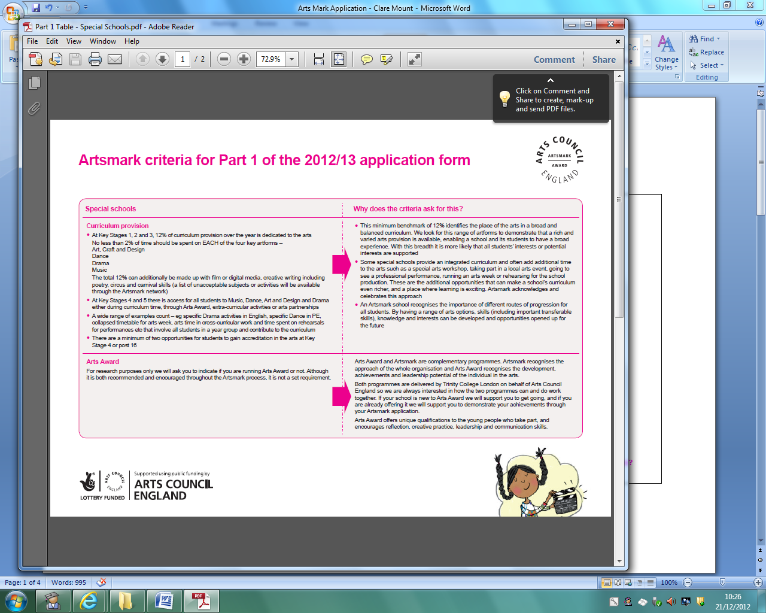
Arts Mark application – Clare Mount Specialist Sports College
PART 1 - Special schools Why does the criteria ask for this?
Curriculum provision
• At Key Stages 1, 2 and 3, 12% of curriculum provision over the year is dedicated to the arts  No less than 2% of time should be spent on EACH of the four key artforms –  Art, Craft and Design  Dance  Drama  Music  The total 12% can additionally be made up with film or digital media, creative writing including  poetry, circus and carnival skills (a list of unacceptable subjects or activities will be available  through the Artsmark network) | Art –  Mon – Y9 (2 periods)  Tues – Y10 (3 periods), Y8 (2 periods)  Wed – Y11 (3 periods),  Thurs – Y11 (2 periods)  Friday – Y7 (2 periods)  14 periods @ 50 mins = 700 minutes.  DT – *???? – Does CH do design through ICT  Mon – Y8 (1 period)  Tues – Y7 (1 period)  Wed – Y7 (1 period), Y8 (1 period), Y9 (1 period), Y10 (2 periods)  Thurs – Y8 (3 periods), Y9 (1 period), Y11 (2 periods)  Fri – Y9 (1 period), Y8 (1 period), Y7 (2 periods)  17 periods @ 50 mins = 850 minutes  Drama –  Mon – Y9 (2 periods)  Tues – Y10 (3 periods), Y8 (2 periods)  Wed – Y11 (3 periods)  Thurs –  Fri – Y7 (2 periods)  12 periods @ 50 mins = 600 minutes  Music –  Mon – Y7 (3 periods)  Tues –  Wed – Y7 (1 period)  Thurs – Y8 (2 periods), Y7 (1 period)  Fri – Y8 (1 period), Y9 (1 period)  9 periods @ 50 minutes = 450 minutes  Dance –  300 minutes at KS4 (see below)  KS3 = ????  Performance in English – Poetry etc  Do students do any additional ARTS on the P-16 carousel or options?  TOTAL = 2900 minutes per week = 48.3 hours  = %
• At Key Stages 4 and 5 there is access for all students to Music, Dance, Art and Design and Drama either during curriculum time, through Arts Award, extra-curricular activities or arts partnerships | Glee Club – (JMc/CV/CC) - Hours  Art Club – (GJ) - Hours  Drama Club (Tuesdays afterschool) (JMc/CV) – Hours  Dance club – Hours. Links to Animal in West Kirby.
• A wide range of examples count – eg specific Drama activities in English, specific Dance in PE, collapsed timetable for arts week, arts time in cross-curricular work and time spent on rehearsals for performances etc that involve all students in a year group and contribute to the curriculum | Dance in PE – (CC)  4 X 50 mins of Entry Level PE per week (Y10&11)  2 x 50 mins of DofE Dance Leadership (Y11)
• There are a minimum of two opportunities for students to gain accreditation in the arts at Key Stage 4 or post 16 | GCSE Art  GCSE Drama  Dance Leadership (Sports Leaders UK Level 1)
• This minimum benchmark of 12% identifies the place of the arts in a broad and  balanced curriculum. We look for this range of artforms to demonstrate that a rich and  varied arts provision is available, enabling a school and its students to have a broad  experience. With this breadth it is more likely that all students’ interests or potential  interests are supported | See above
• Some special schools provide an integrated curriculum and often add additional time  to the arts such as a special arts workshop, taking part in a local arts event, going to  see a professional performance, running an arts week or rehearsing for the school  production. These are the additional opportunities that can make a school’s curriculum  even richer, and a place where learning is exciting. Artsmark acknowledges and  celebrates this approach | Special Arts workshop – Culture & Creativity Prepares Day (5 hours) – preparing Olympic banners (5 hours prep).  Self-Portraits -  Balloons Project (5 hours) – Olympic values dance and music.  Poetry Day (5 hours) – Curtis Watts.  Local Arts Events/School Production – Shakespeare Festival (JMc to provide hours preparing and performing)  Christmas show –  Assemblies –  Wirral Dance Festival (CC) –  Combined events – Machismo  Holiday dance camps -  Professional Performance – Pantomime (2 hours), JMc other trips
• An Artsmark school recognises the importance of different routes of progression for  all students. By having a range of arts options, skills (including important transferable  skills), knowledge and interests can be developed and opportunities opened up for  the future | Case studies of students show that they we have students who have progressed onto College to do dance and other performing arts courses (e.g. Stacey G).
Arts Award
For research purposes only we will ask you to indicate if you are running Arts Award or not. Although it is both recommended and encouraged throughout the Artsmark process, it is not a set requirement.  Arts Award and Artsmark are complementary programmes. Artsmark recognises the  approach of the whole organisation and Arts Award recognises the development,  achievements and leadership potential of the individual in the arts.  Both programmes are delivered by Trinity College London on behalf of Arts Council  England so we are always interested in how the two programmes can and do work  together. If your school is new to Arts Award we will support you to get going, and if you  are already offering it we will support you to demonstrate your achievements through  your Artsmark application.  Arts Award offers unique qualifications to the young people who take part, and  encourages reflection, creative practice, leadership and communication skills | Students have the opportunity to act as leaders through Dance Leadership, Peer mentoring and Singing Leaders (Glee Club). These skills encourage many of them to become Sports Leaders and show leadership skills across the school in taking part in school council, Subject Change Teams, Learning Leaders, and Games Makers.  Arts Award - Looking to develop at L3 from Spring 2013 (CC).
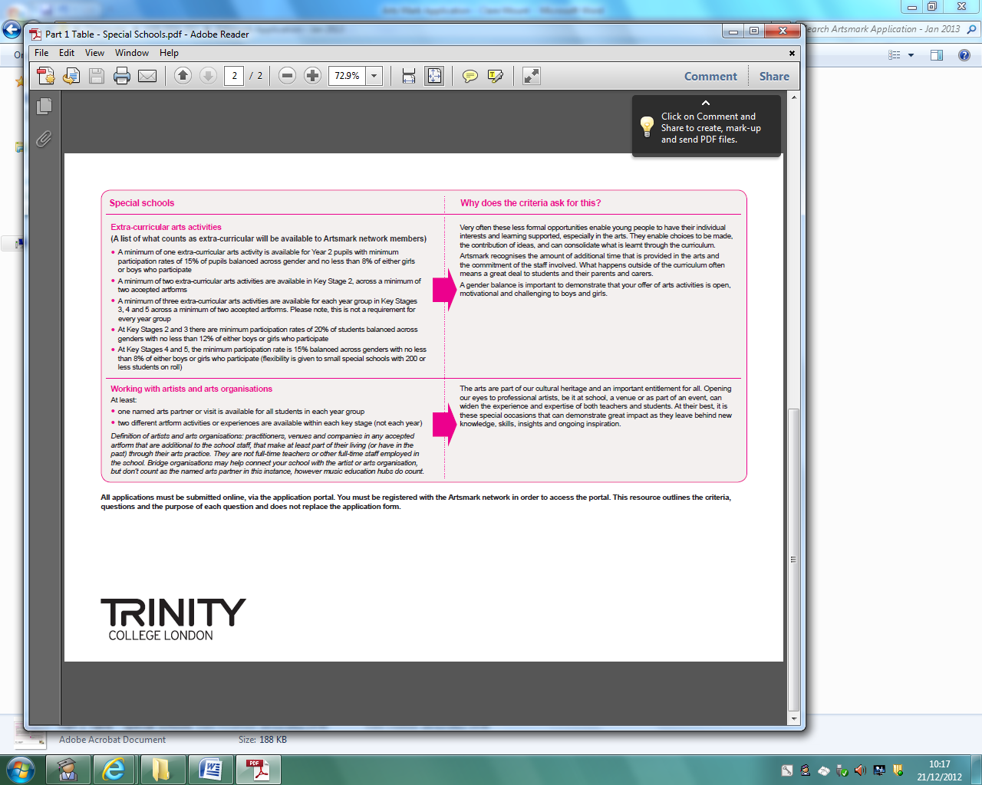
Extra-curricular clubs include:
Glee Club
Arts Club
Card Craft club
Dance club
Drama club

Working with artists and arts organisations:
- Floral Pavillion Shakespeares Festival.
- Pantomime at School.
- Visiting organisations – Balloons Project, Curtis Watts.
- School productions / Termly shows.
- Performances in Assemblies.
- Dance coaches – Wirral Youth Theatre.

Proposed link to Poetry day at National Football Museum in Manchester.

