Clare Mount Specialist Sports College

School Improvement Plan
2017/18 (and beyond)

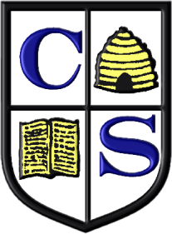

Contents

Part 1

School aims, vision and values 3

Summary of achievements 2016/17 4
Pupil attendance/behaviour/attainment targets for the
academic year 2017/18

Priorities for academic year 2017/18 5

Part 2

Whole-school improvement plan 6-19

Outcome-Driven Matrix 7

Clare Mount Health and Mental Well-Being Matrix 19

A more detailed copy of the school improvement plan containing every department development plan can requested from Assistant Head Linda Evans.

VISION
Following London 2012, Clare Mount adopted the Paralympic vision of our pupils becoming ‘role models’ and ‘catalysts for change’ in attitudes to people with special educational needs and disabilities. This vision has inspired youngsters (and their families and staff) to adopt an ‘I can’, solution-focused mentality towards achieving the best possible outcomes in and beyond school.

At Clare Mount we firmly believe in developing the ‘whole child’ and that if pupils enjoy school and have appropriate strategies in place to support their mental health and well-being then academic success will follow. Such a philosophy towards education has seen improved academic outcomes year on year, with pupils also being prepared personally, socially and emotionally for “opportunities, responsibilities and experiences of later life” (NC 2016). The opportunities include taking on roles such as kit carriers at the London 2012 Paralympics, Junior Golf Supervisors at The British Golf Open (2014), part of The Pack volunteering programme at the Rugby World Cup 2015, participants and leaders at the UK and World School Sport Education Games in Stoke Mandeville / Much Wenlock and Greece respectively, and ‘Runners’ at the London 2017 Para Athletics and World Championship Athletics inside the Olympic Stadium. In terms of the latter the motto of the Games was ‘See the Best’, ‘Be the Next’. Carry this motto forward, we hope that the young people and staff at Clare Mount will be inspired by those around them and want to leave the Clare Mount uniform in a better place than they found it (Legacy, James Kerr, 2013):

“Leaders design and create an environment which drives the high performance behaviours needed for success. The really clever teams build a culture that drives the behaviours they need” (Owen Eastwood).

EDUCATIONAL OUTCOMES:
Our key goal for learning and development of pupils (and staff) at Clare Mount is that we foster a ‘learning culture’ that (a) equips pupils with the knowledge, skills, attitudes and values to be successful in work, family and the community, and (b) to nurture and inspire staff to be open to new approaches and create and share best practices, especially in inclusion and differentiation, for the benefit of all.

AIMS
We will provide a safe, stimulating, enjoyable and creative environment where all pupils flourish and are given the tools to achieve their potential. We will ensure that every pupil achieves their full potential by:

    - “Child-centred” – place students at the heart of everything we do
    - working together as a team
    - providing a balanced and appropriate curriculum
    - encouraging curiosity, creativity, enthusiasm and reflection
    - promoting independence, confidence, resilience and well-being
    - instilling a life-long love of learning
    - encouraging self-esteem and respect for others
    - ensuring our pupils are equipped to meet the challenges of the future.

Achievements academic year 2016/17

Analysis to results from 2015-2017:

- 100% of pupils have achieved at least 1 GCSE or equivalent since 2015.

Average number of GCSEs or equivalents:

Year | 2015 | 2016 | 2017 | 2018
Average GCSEs or equivalents | 4.6 | 5.0 | 5.0

Percentage of pupils in Year 11s achieving 5 or more GCSEs or equivalent:

Year | 2015 | 2016 | 2017 | 2018
5 GCSEs or equivalents | 38% | 59% | 68%

- Our aim is that every pupils will leave Year 11 with 5 or more certificates at Entry Level or equivalent. As such, we have created a Progess 8 pathway and an alternative skills pathways linked to the learning needs of our pupils.

Behaviour:

Behaviour is ‘outstanding’ and Ofsted (June 2016) described the school as an ‘Oasis of calm’. Despite this Clare Mount is constantly looking at ways to support pupils to make the right ‘choices’ and to ‘self-regulate’ their behaviour.

The school monitors incidents and behaviours through SIMs and puts appropriate interventions in place.

Case studies (through Action Research) reflect the impact of our Positive Behaviour policy.

Attendance: Pupils enjoy being in Clare Mount which is reflecting in their attendance (Ofsted 2016).

Year | 2014-5 | 2015-6 | 2016-7 | 2017-8
% of attendance | 94% | 95.3% | 95% | 95%
*Issues such as removing escorted transport for SEN pupils have impacted slightly on attendance for some pupils. Clare Mount have supported appeals from parents. Learning

Priorities academic year 2017/18

Clare Mount is committed to going “Beyond Outstanding” and ensuring we maintain outstanding teaching and learning outcomes for pupils (and staff) inside and beyond the classroom. We aim to use progress data to:

SIMS:
- Systematically inform high quality planning, teaching and assessment;
- Identify, implement and review appropriate strategies to support and stretch every pupil to overcome potential barriers to learning; and
- Monitor school performance in line with our learning pathways, including ‘Progress 8’ measures at GCSE, compared to similar successful SEN schools.
- Share best practice.

Focus Priorities academic year 2017/18

- FP1 – To support the successful transition of an ever-expanding Year 7 cohort into Clare Mount.

- FP2 – To facilitate the move of the 6th form into a new building, using this as a stepping stone to easing the transition into either College or pathways beyond Clare Mount.

- FP3 – To focus our Action Research around the Health and Mental Well-being of pupils (and staff) to bring about ‘whole school’ improvements around attendance, confidence and social skills.

- FP4 – To establish an “I am”, “I can”, “I have” solution-focused model to improving and managing emotions and behaviours (The Resilience Doughnut).

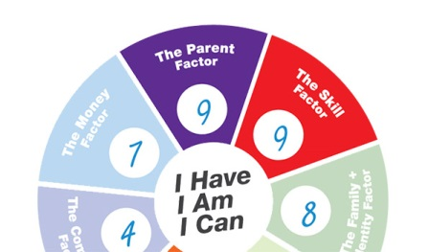
Whole School Improvement Plan
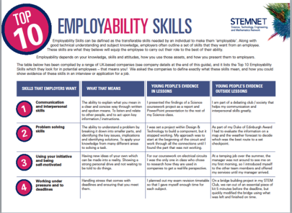

2017-18 (and beyond)

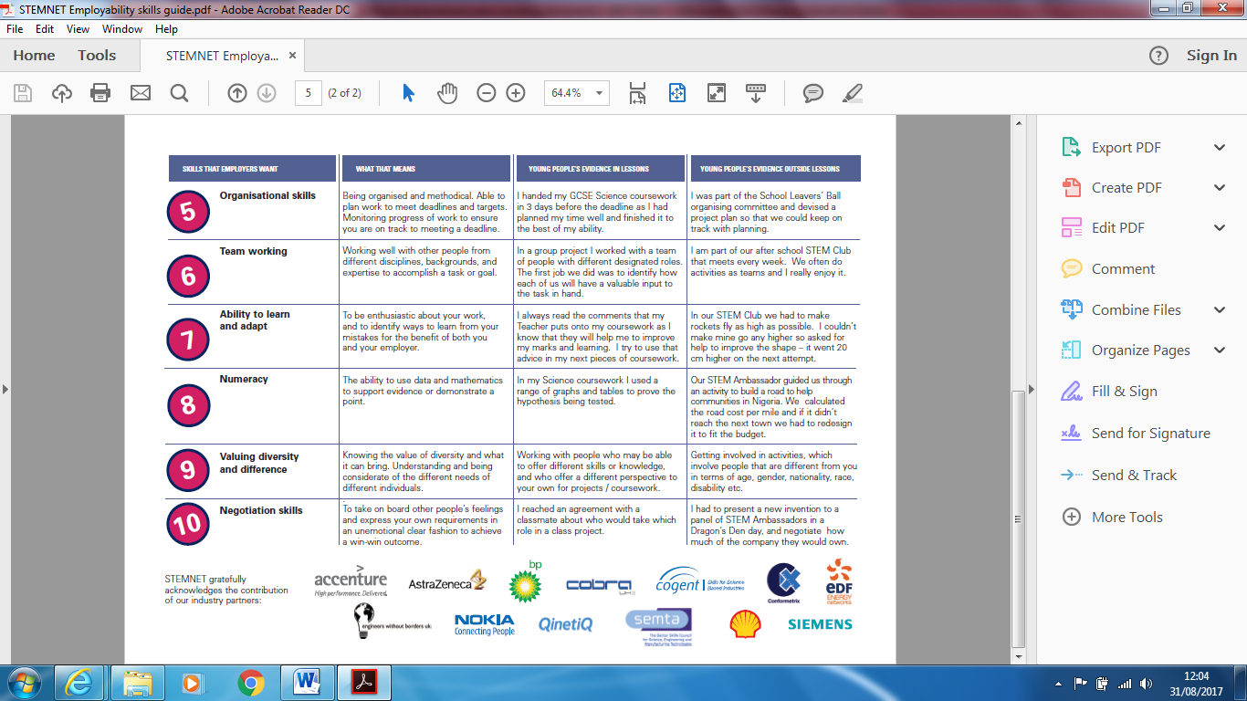
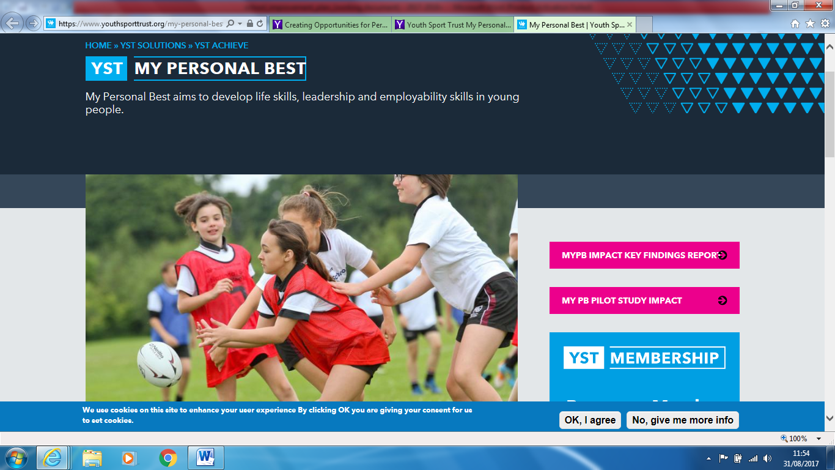
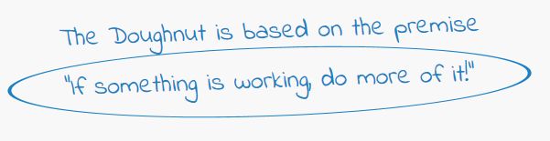
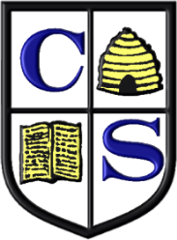



LEARN – INTERACT - ENGAGE
Outcome Driven SIP Matrix: Our goal for the learning and development of pupils at Clare Mount centres around helping them develop the appropriate knowledge, skills, attitudes and values to be successful in work, family and community. At Clare Mount we put the child at the centre of our thinking. With this in mind all the projects, courses, interventions and strategies we put in place are about developing the independence, communication and social skills of our pupils so that they can achieve the best possible outcomes academically in preparation for College and / or life after school. In considering ‘outcomes’ for pupils our development plans and teaching will focus on “What will our pupils be able to do by the end of school?”. The key outcomes for pupils at Clare Mount are detailed in the matrix below:

Outcomes for feeling settled and safe and achieving emotional self-regulation (Autism Accreditation). | Outcomes for improved Mental Health and Well-being: COPE Message: “The young person can accomplish whatever it is that is important to them”.  http://www.cope2thrive.com/ | Outcomes for achieving My Personal Best:  https://www.theresiliencedoughnut.com.au/about-the-resilience-doughnut/ | Outcomes for developing employability skills (KS4 and P-16) for life after Clare Mount. | Additional Outcomes:
Pupils (staff and family) will be taught how to understand and enable autistic pupils by:  - Identifying and addressing Differences in Social Communication (e.g. use schedules, visuals, adapt resources, calm environment).  - Developing self-reliance and problem solving (e.g. use timers to help cope with change and give clear instructions, transition plans).  - Accessing sensory experiences as required (sensory rooms, sensory garden, movement breaks, ear defenders and fidgets).  - Self-regulation and emotional well-being (e.g. calm and de-cluttered environment, use of EHCPs and emotional thermometers, developing positive relationships and positive self-esteem). | Pupils will develop tools to help them:  - Have good self-esteem.  - Show a sense of optimism.  - Be resilient.  - Recognize their support mechanisms (family/friends/teachers).  - Communicate effectively with others around their needs and emotions.  They will have basic knowledge of the importance of:  - Good sleep and physical health.  - Health eating.  - Physical activity.  School will support them to:  - Have positive (life) experiences.  - Develop solid coping and cognitive behavioral skills.  - Offer some financial security (e.g. pupil premium, bids, friends of Clare Mount). | This is ME:  Self-Management (Looking after my things and be on time).  Integrity (Be honest).  Resilience (Don’t Give up)  Responsibility (Don’t blame others).  Self-Motivation (I want to ...)  SOCIAL ME:  Communication (ACTIVE LISTENING)  Communication (SPEAKING)  Collaboration – TEAMWORK  Empathy  Motivating and influencing others  THINKING ME:  Innovation (My ideas)  Evaluation (How did I do? How did it go?) | Lessons will focus on the following skills:  This is ME:  - Organizational skills (able to plan and monitor to meet deadlines).  - Using initiative and being self-motivated (ideas and personal drive).  - Coping with pressure / deadlines (Handling stress).  SOCIAL ME:  - Communication and interpersonal skills (Explain, listen, relate).  - Negotiating skills (take others feelings on board and express your own to achieve win-win).  - Team working  - Valuing diversity and difference (being considerate of different needs).  THINKING ME:  - Ability to learn and adapt (enthusiastic learning able to learn from mistakes)  - Problem Solving skills (break down issue and find solutions).  - Numeracy (use data and maths to make a point) | A series of important outcomes found in Departmental Development Plans, Cross-curricular projects and Schemes of Work (e.g. learning to manage money), and important life skills enforced outside the curriculum (e.g. independent travel).

- FP1 – To support the successful transition of an ever-expanding Year 7 cohort into Clare Mount.

Outcomes for learners: New pupils will feel ‘settled and safe’ in Year 7.

Targets to bring about improvement | Actions required | By when? | Staff responsible for actions | Success criteria | Staff responsible for monitoring success | Resources required | Progress made?
Ease transition into Year 7 for our largest ever intake of 41 pupils across 5 forms of entry. | Establish a ‘buddy’ / mentor system using older pupils.  Engage pupils in new opportunities (e.g. HSBC Go Ride skills sessions and a Beyond the Baseline masterclass). | Oct 2017  Dec 2017 | Form tutors and H of P-16.  PE Dept. | Less incidents recorded on SIMs in Summer 2 compared to other times of the year.  Positive parents evenings / questionnaires and annual reviews  ‘Who AM I?’ reviews by pupils.  See outcomes for ‘settled and safe’ in Year 7 listed above. | SCr  DK  DK | Assign P-16 to different classes.  Secure ILM funding for Matthew O Connell.  Funding from YST for BTB and HSBC projects.
Redesign and develop the appropriate sensory space / environment for pupils. | - Transform storage rooms into outbreak rooms.  - Complete sensory garden.  - Apply to The Lord Tavernors for a Sensory package of equipment.  - Apply for funding through Grants4Schools to modernize the library as a learning space. | Sept 2017  Oct 2017  Dec 2017  April 2018 | Caretaker / Business Manager  Caretaker / Business Manager  Caretaker / Business Manager  DK / TL | The school environment will continue to meet the changing sensory needs and demands of our pupils as reflected in the appropriate implementation of the EHCPs. | LE / AW / Head / DK | KW to continue to request funding from the LEA.  DK to apply for grants and have dedicated time to do this.
Engage parents / carers into the Clare Mount family. | - Run a Family Welcome for new Year 7 families.  - Organise ASC training for parents / carers  - Offer a Youth Connect 5 ‘Resilience’ training programme to new families.  - Invite parents to engage in established working groups / events (e.g. Family Sports Nights, Friends of Clare Mount. | Oct 2017  Dec 2017  Jan 2018  June 2018 | Learning Mentors  TR / SCr  Learning Mentors  DK / Friends of CM | At least 20 family members attending Family Welcome.  At least 10 families engaging in ASC training and Youth Connect 5 programme.  At least 10 families involved in family sport night and activities of friends of Clare Mount.  Positive feedback in annual reviews / questionnaires / evaluations. | SCr / Learning Mentors | Dedicated time for SCr / TR and Learning Mentors to run events.

- FP2 – To facilitate the move of the 6th form into a new building, using this as a stepping stone to easing the transition into either College or pathways beyond Clare Mount.
Outcomes for learners: More P-16 pupils will have the confidence and skills to take the ‘next step’ into College or employment by July 2018.

Effectiveness of 6th form provision, where applicable
Targets to bring about improvement | Actions required | By when? | Staff responsible for actions | Success criteria | Staff responsible for monitoring success | Resources | Progress made?
Post 16 pupils will all attempt to complete their National Citizen Service in order to develop skills for work, boost their CV and work readiness, make a difference in their local community and develop skills for the future and independent living. | - Induction afternoon completed.  - Evolve submitted. Register NCS pupils for Adventure.  - NCS input to curriculum in Autumn 2017.  - Social Action agreed and delivered.  - Graduation. | Summer 2017  26th-28th Sept 2017  Feb 2017  April 2017 | DK  CCS/SM  Tutors  NCS | All P-16 have completed an Induction in Summer 2017.  90% of P-16 to complete an Adventure at Kingsway Doncaster in September 2017.  75% of P-16 to show employability skills by delivering a Social Action and Graduating with an NCS certificate. | CCS / SM / DK | £20pp from pupils for Adventure. NCS to pay rest.
Revamp and review the P-16 curriculum to ensure more pupils are ready to take the ‘next step’ into College. | - New Head of P-16.  - Skills-based curriculum.  - More college visits.  - Enterprise for all.  - Review of P-16 Admissions policy.  - P-16 Annual Reviews  - Next Steps Event.  - Liaison with Colleges / LA. | Summer 2017  All year  Sept 2017  Oct 2018  Jan 2018  On-going | CCS / Head | More Year 11 and P-16 pupils completing their ‘Passport to Work / College’ and feeling they have the right skills to take the next step.  Reduced numbers of pupils wishing to remain in the 6th form at Clare Mount. | CCS / Head | New mini-bus funded by Morgan Foundation.  Greater timetabling flexibility focusing on skills for college.
Transition into the new CLC building for P-16 at the Kingsway Academy. | - Ensure all furniture and ICT is in place.  - Travel training and addressing issues around being on a split site.  - Update of sensory spaces and personal schedules.  - Joint project with Kingsway to break down barriers and educate pupils.  - Early decision on the future use of the CLC or development of space on the Clare Mount site.  - On-going communication and dialogue with parents / carers. | Sept 2017  Oct 2017  Dec 2017 | CCS / SLT / ICT  CCS and Natalie Faulkner at Kingsway | Annual reviews and questionnaires will show that pupils will feel settled, safe and inspired by the move to the CLC.  By the end of the year more pupils will feel ready to take the ‘next step’ into college having developed their independence skills and ability to manage change.  P-16 will continue to be role models and catalysts for change in the lower school (e.g. mentors). | CCS / SLT | School budget.  Costs for 2017-2018 agreed.

- FP3 – To focus our Action Research around the Health and Mental Well-being of pupils (and staff) to bring about ‘whole school’ improvements around attendance, confidence and social skills.
Outcomes for learners: Personal health and mental well-being is essential to safeguarding pupils at risk of self-harm. Developing happy pupils with high self-esteem and ‘I can’ attitudes is the foundations for future success academically and in life.

Effectiveness of leadership and management
Targets to bring about improvement | Actions required | By when? | Staff responsible for actions | Success Criteria | Staff responsible for monitoring success | Resources | Progress made?
To train, develop and empower staff to have the appropriate knowledge and tools to support their own health and mental well-being and that of our pupils.  Using neuroscience (Chimp Management), Cognitive Behavior Therapy (COPE) and other tools from our Health and Well-being matrix (Appendix 1) to help staff complete Action Research aimed at helping young people (and themselves) gain insight into themselves and ‘normalize’ the emotional changes they are experiencing, and develop coping strategies, building self-esteem for healthy adulthood. | - Share Health and Well-being matrix with all staff.  - Organize a Chimp Management training introducing the model, applying it to self and others.  - Introduce COPE / My Personal Best programme to staff and implement pilot.  - Organize a Mental Health First Aid training day and get staff attending to disseminate learning.  - Pilot Youth Sport Award in Year 9/8.  - Introduce Young Health Ambassadors to school.  - Complete SHEU survey and health week. | Sept 2017  4/9/17  29/9/17  Autumn / Spring  Autumn  Jan 2018 | DK  DK / All staff to take part.  DK  Heads of Year / Pastoral Heads  CV/SSt  DK  DK/PE Dept/SB | Chimp Mgt: Registers and feedback will show that all staff will be familiar with Chimp Management and be able to support students to ‘discover the person they want to be, and to take ownership and an active role in achieving this’. Achievable and measurable outcomes:  - Understand the mind, what helps us be more resilient.  - Recognizing and managing stress.  - Goal setting and confidence building.  - Consider friendships and how they influence actions/reactions.  - Strategies for communicating effectively with others.  COPE: Outcomes will be reducing negative thoughts (cognitive restructuring), increasing pleasurable activities (behavioral activation), Improving assertiveness and problem-solving (homework), becoming own therapists, changing thoughts from negative to positive feelings and behaviors.  YHA: Evidence of giving pupils ownership by establishing a unique Award that puts health and wellbeing at the heart of developing the UK’s young people. | DK / All staff  COPE: DK / NB  HOY/JM.  CV/SSt  DK  DK/PK | CPD budget for Chimp Mgt.  Healthy Futures Network and University of Chester to fund COPE.  CPD budget to fund Mental Health First Aid.  YST to fund Youth Sport Award and YHA project  £150 SHEU survey

- FP4 – To establish an “I am”, “I can”, “I have” solution-focused model to improving and managing emotions and behaviours (The Resilience Doughnut).
Outcomes for learners: Build resilience and promote well-being of pupils (staff, parents and families).

Personal development, behaviour and safety
Targets to bring about improvement | Actions required | By when? | Staff responsible for actions | Success Criteria | Staff responsible for monitoring success | Resources | Progress made?
Embed the key features of the Resilience Doughnut (RD) model into our personal development, behavior and safety (safeguarding) approaches making them ‘strength-based’ and ‘solution-focused’. | - Following an introduction to the RD model, organize a meeting of LN and John Sheppard to create an action plan for delivery in school.  - LN to make this the focus of her Leadership training with Weatherhead Teaching School Alliance.  - Train LN and JM as Level 1 trainers working in school to improve resilience and well-being.  - Pilot the ‘I have, I am, I can’ model with a targeted Year / group of pupils.  - Role RD model out to other pupils ready for whole school use in Sept 2018.  - Further staff CPD /workshop for parents / carers led by LN/JM ready for Sept 2017. | Sept 17  Sept 17  Oct-Dec 17  Jan-Mar 18  Summer 18  Summer INSET 18 | DK/LN/JM/ John Sheppard  LN  LN/JM  LN/JM  HOY  LN/JM | Establish a common language and approach to all our work on resilience, well-being and achievement across the whole school community.  Enhancing a positive culture of growth both inside and outside the classroom.  Embed use of ‘I Have, I Am, I Can’ so pupils have at least 3 of the 6 Factors to focus positively on in any meeting / discussion.  - Money Factor  - Parent/Family/ Identity Factor  - Skill Factor  - Education Factor  - Peer Factor  - Community Factor | LN/JM | £500 of School Budget to work with John Sheppard.  £500 towards cost of training staff as Level 1 Trainers.

- School Improvement Development Plan: Centre of Excellence:
Outcomes for learners: PE/Sport Changes Lives.
HUB School aims: Our VISION is to ensure that every young person is provided a sporting chance to succeed in life through increased equality of opportunity.
We aspire to empower and enable others to see the importance of Inclusive high quality PE, physical activity and school sport provision for all young people.
Ensuring that it is: Inspiring: something that they want to take part in. Accessible: something that they can take part in. Meaningful: something that they can actually benefit from.
School Games aims: Keeping competitive sport at the heart of schools and provide more young people with the opportunity to compete and achieve their personal best. By 2020 the School Games will be continuing to make a clear and meaningful difference to the lives of even more children and young people.

Sports College Development Plan
Targets to bring about improvement | Actions required | By when? | Staff responsible for actions | Success Criteria | Staff responsible for monitoring success | Resources | Progress made?
Deliver the Key Performance Indicators expected of an Inclusion Hub School for YST and delivery partners. | - Create Development Plan for Watersport, Extreme Sport and Wheelchair Sport Hubs.  - Girls Active development plan.  - Attend Hub School Development Day.  - Work with cluster to pilot / deliver participation and CPD in British Cycling Skills Award (HSBC GO Ride) in 10 schools (£900) and establish the Tennis Foundation Give It to Your Max Hub (£3000 over 3 years). | Oct 2017  Oct 2017 | SG/DK/JWh  GK  DK/SG | Increased focus on identifying the needs of young people through focus groups.  Ensures that there is a connected approach across the curriculum in the engagement of young  people in a diverse range of sport roles.  Shifts the intervention to focus on the least active/engaged within both primary/ secondary  school settings (Up to KS3) | DK/JWh/SG / LH | Completion of annual SHEU survey (£150 Jan 2018)  Designated funding assigned to HUB schools.  £5500 core for CPD/ Leadership/Events.  £900 per Hub.
Successfully deliver YST Innovative Projects to develop best practice. | - Attend SEDY Conference and create a PAPAI delivery plan with Karen McNicholl at Liverpool Hope around 1 to 1 support for SEND youngsters in the community.  - Work with Liverpool SSP and SOGB to establish a programme of PMLD training and events. | Autumn 2017 for a Spring launch.  Autumn – Through Year | JWh  JWh | Greater engagement of young people with SEN in community sport.  More accessible School Games offer for PMLD youngsters. | JWh / DK | £2000 YST funding  £2000 YST funding
Deliver a HQ, engaging, accessible and inspiring School Games offer. | - Plan a calendar to include a minimum of 22 events across 10 different pathways. | All year | SG | YST KPI data return. | SG | SGO Funding.  Base with other Wirral SGOs.
Celebrate the successes of the Sports College and share best practice | - Re-apply for AfPE Quality Mark with distinction.  - Organise verifier visit. | Oct 2017  Nov 2017 | DK / PE Dept  Bob Saunders | Successful re-accreditation by January 2018. | DK | £250 cost.
Young people leading the way | - SLUK: Re-introduce a Level 3 Sports Leaders Award for P-16.  - YSA: Pilot the Youth Sport Award in KS3 and attend Award Co-ordinator Training.  - YHA: Attend Young Healthy School Ambassador Training and create individual action plans. | Sept 2017  Sept 2017  Sept 2017 | SSt  CV /SSt  DK | SLUK: Clear pathway to College and employability skills.  YSA: The Youth Sport Award will to develop character traits (e.g. leadership / employability skills), improve attitudes to learning / behavior / transition, and tackle inactivity and physical well-being.  YHA: 10 young people will take on leadership roles to create more opportunities in OSHL for others and help them make healthy living choices (achieving a Level 1 Award). | SSt/DK  SSt (PE CatalYST)  DK | Cost of registering L3 Award through exam budget.  Free pilot organized by SSt. Cover for training (18th September).  1 of 10 pilot schools. (26th September)
Develop the tutoring and mentoring skills of the PE/Sports College team | Attend:  - Premier League Reading Stars Primary Active Leaders tutor training.  - Youth Sport Award tutor training.  - Inclusive PE tutor training  - Autism in PE tutor training | Sept 2017  Sept 2017  Oct 2017  Nov 2017 | JWh  CV  JWh  DK/JWh | To support colleagues to be able to use sport as a vehicle to help young people achieve their personal best (whatever level that might be) so that they have the right character and resilience to try new things and keep going when they face challenges. | DK/SSt/JWh | Free training organized through YST.  Costs of organizing ASC course to be passed on to participants.

Outcomes for learners: Staff will be more confident and competent in delivery outstanding, inclusive practice.

Collaboration and Continuing Professional Development Plan
Targets to bring about improvement | Actions required | By when? | Staff responsible for actions | Success Criteria | Staff responsible for monitoring success | Resources | Progress made?
To increase the range of Teaching School Alliances that Clare Mount engages with and supports to share best practice, including our ASC outreach programme. | - Maintain training course delivery for the Weatherhead Teaching School Alliance.  - Increase this offer to include the Heath Teaching School Alliance in Runcorn.  - Support The Oakwood Teaching School Academy to introduce an Action Research model. | Sept & Dec 2017  Sept & Dec 2017  Autumn 2017 | DK / CCS / TR  DK / CCS / TR  DK | Evaluation forms will show that trainee teachers are more confident and competent in their behavior management and inclusive practice.  A successful case study of the impact of Action Research at Oakwood will allow Clare Mount to offer the ‘service’ to other Teaching School Alliances and individual schools. | DK  DK | Time to attend training and plan / prepare.  Time to travel to Manchester.
To establish International Partnerships through our training and delivery. | - Host a Connecting Classrooms ‘Collaboration and Communication’ CPD programme.  - Apply for £3000 grant to establish an International link with The Babylon National School in Nepal.  - Share best practice in Inclusion in PE by attending the SEDY Conference in Amsterdam.  - Send a member of staff and a School Leader to Nepal.  - Run a ‘Dreams and Teams’ programme with a Polish School.  - Expand engagement with ISF/NCSS. | Sept & Dec 2017  Sept 2017  Nov 2017  Feb 2018  Summer 2018  Summer 2018 | DK  DK  DK /JWh  DK  DK / MKw  DK/JWh/SSt | 10 staff will have developed ‘outstanding teaching’ practice through sharing ‘communication and collaboration’ ideas.  Compelling partnership plan presented to the British Council.  Replicate the PAPAI programme piloted in Holland, Finland, Portugal and Italy with Liverpool Hope University.  Case study and cultural exchange.  Utilise skills and experiences of staff (e.g. Polish TA who is a qualified PE teacher).  Another group of pupils / staff will represent UK at World School Sport Education Games. Inaugural ISF Inclusive Games in Portugal (July 2018). | DK  DK  DK/JWh  DK  DK/MK  DK | Free training from British Council via Creative Education.  £3000 towards travel and programme costs.  £2000 from YST for travel and project.  To coincide with half term.  Planning time / ICT link  Fundraising activities through Friends of CM.

APPENDIX 1 – CLARE MOUNT HEALTH & MENTAL WELL-BEING MATRIX:

 |  | 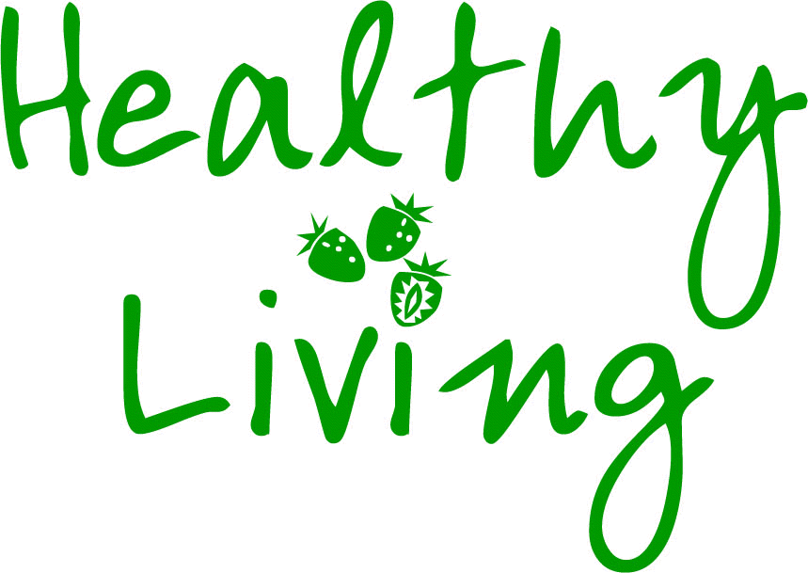    
Food and Diet | Physical Activity | Physical Health
Breakfast club  Healthy Tuck shop | Student enjoyment of PE | Sleeping patterns, personal hygiene & dental health
Links to Lifestyle Weight Management Team | S.T.E.P. Inclusive PE | Healthy, Active lifestyle education
Healthy Eating – Food Champion / School Food Plan - Annual Health Week | Active playgrounds (zumba/clubs) | Active Classrooms (Maths of the Day), Yoga Factory and relaxation / Mindfulness
Give Up Loving Pop (GULP) –  Drinking (Water intake) | At least 2-hours curriculum PE | Research studies with Universities (DRILL)
Healthy cookery based in the Eatwell Plate. Food Fit for life Food Choices | Underground training | Annual SHEU survey to track trends
Reduction in sugar intake (Change4Life messages) | Emotional health and well-being
 | National Autistic Society Accreditation / CPD / Scheduling / Support plans |     Bullying
Personal Information | SHARP system (School Help Advice Reporting Page) | Holistic safeguarding programmes for schools
PSHE – Personal, Social and Health Education | Emotional well-being support services (multi-agencies) | Bullying awareness
SMSC – Spirtual, Moral, Social and Cultural  Positive Food Choices | School nurse and trainee nurse placements (University of Chester) | E-safety, SIMs and pastoral system
Student survey / Focus groups / School Council Voice (Votes for Schools) / Leadership / Youth Health Ambassadors | Emotional well-being & resilience - Youth Connect 5 / Family sport nights / Family Welcome (parent engagement) | Communication with parents
Mental Health and Well-being Action Research focus (2017-18) | COPE – Creating Opportunities for Personal Empowerment | 
 | Thumps Up (Cognitive Behaviour Therapy) | Employability and Life skills
School and Future Plans | Mental Health First Aid Training for Schools | Skills for Health
Person Centred-plans | Relationships education | Careers Advice and Guidance
Future plans after leaving school | Experiences which build confidence and self-esteem | Residential experiences
Future plans after leaving school | Resilience Doughnut | Work experiences
Future plans after leaving school | Chimp Management | Unique experiences (e.g. Kit carriers, Games Makers).

